Appendix 3. SUPPLEMENTARY TABLES AND FIGURES

Supplementary Table S1. Simulation settings and results of the FP-FN occupancy model performance. The model performance of each scenario (row in the table) was assessed using the root mean squared error (RMSE) of the abundance estimates based on 200 simulated datasets. $ψ$: occupancy probability, $ϕ$: availability probability, $S$: number of sites, $J$: number of occasions, Prop verif: proportion of verified images, $λ$: true positive rate, $ω$: false positive rate, $μ_{0}$: mean FP score (logit-transformed), $μ_{1}$: mean TP score (logit-transformed), $σ_{[0,1]}^{2}$: standard deviation of TP and FP scores distributions, and RMSE: root mean squared error.
$$ψ$$ | $$ϕ$$ | $$S$$ | $$J$$ | Prop verif | $$λ$$ | $$ω$$ | $$μ_{0}$$ | $$μ_{1}$$ | $$σ_{[0,1]}^{2}$$ | RMSE
0.2 | 0.2 | 30 | 10 | 0.1 | 1 | 0.4 | 0 | 1.386 | 0.5 | 0.114
0.2 | 0.2 | 30 | 10 | 0.3 | 1 | 0.4 | 0 | 1.386 | 0.5 | 0.103
0.2 | 0.2 | 60 | 10 | 0.1 | 1 | 0.4 | 0 | 1.386 | 0.5 | 0.064
0.2 | 0.2 | 60 | 10 | 0.3 | 1 | 0.4 | 0 | 1.386 | 0.5 | 0.066
0.2 | 0.6 | 30 | 10 | 0.1 | 1 | 0.4 | 0 | 1.386 | 0.5 | 0.071
0.2 | 0.6 | 30 | 10 | 0.3 | 1 | 0.4 | 0 | 1.386 | 0.5 | 0.066
0.2 | 0.6 | 60 | 10 | 0.1 | 1 | 0.4 | 0 | 1.386 | 0.5 | 0.048
0.2 | 0.6 | 60 | 10 | 0.3 | 1 | 0.4 | 0 | 1.386 | 0.5 | 0.051
0.6 | 0.2 | 30 | 10 | 0.1 | 1 | 0.4 | 0 | 1.386 | 0.5 | 0.095
0.6 | 0.2 | 30 | 10 | 0.3 | 1 | 0.4 | 0 | 1.386 | 0.5 | 0.088
0.6 | 0.2 | 60 | 10 | 0.1 | 1 | 0.4 | 0 | 1.386 | 0.5 | 0.082
0.6 | 0.2 | 60 | 10 | 0.3 | 1 | 0.4 | 0 | 1.386 | 0.5 | 0.077
0.6 | 0.6 | 30 | 10 | 0.1 | 1 | 0.4 | 0 | 1.386 | 0.5 | 0.082
0.6 | 0.6 | 30 | 10 | 0.3 | 1 | 0.4 | 0 | 1.386 | 0.5 | 0.079
0.6 | 0.6 | 60 | 10 | 0.1 | 1 | 0.4 | 0 | 1.386 | 0.5 | 0.058
0.6 | 0.6 | 60 | 10 | 0.3 | 1 | 0.4 | 0 | 1.386 | 0.5 | 0.056

$$min\left(N_{st}\right)$$ | $$max\left(N_{st}\right)$$ | $$S$$ | $$T$$ | Prop verif | $$p_{h}$$ | $$p_{a}$$ | $$min\left(π_{s}^{tp}\right)$$ | $$max\left(π_{s}^{tp}\right)$$ | $$μ_{0}$$ | $$μ_{1}$$ | $$σ_{[0,1]}^{2}$$ | RMSE
Simulation experiment 1:
10 | 100 | 20 | 1 | 0.1 | 0.8 | 0.7 | 0.5 | 0.5 | 1.386 | 1.734 | 0.5 | 0.164
10 | 100 | 20 | 1 | 0.3 | 0.8 | 0.7 | 0.5 | 0.5 | 1.386 | 1.734 | 0.5 | 0.130
10 | 100 | 20 | 1 | 0.5 | 0.8 | 0.7 | 0.5 | 0.5 | 1.386 | 1.734 | 0.5 | 0.108
10 | 100 | 20 | 1 | 0.1 | 0.8 | 0.7 | 0.5 | 0.5 | -0.405 | 1.734 | 0.5 | 0.153
10 | 100 | 20 | 1 | 0.3 | 0.8 | 0.7 | 0.5 | 0.5 | -0.405 | 1.734 | 0.5 | 0.126
10 | 100 | 20 | 1 | 0.5 | 0.8 | 0.7 | 0.5 | 0.5 | -0.405 | 1.734 | 0.5 | 0.106
10 | 100 | 20 | 1 | 0.1 | 0.8 | 0.7 | 0.5 | 0.5 | 0.405 | 1.734 | 0.5 | 0.161
10 | 100 | 20 | 1 | 0.3 | 0.8 | 0.7 | 0.5 | 0.5 | 0.405 | 1.734 | 0.5 | 0.129
10 | 100 | 20 | 1 | 0.5 | 0.8 | 0.7 | 0.5 | 0.5 | 0.405 | 1.734 | 0.5 | 0.107
Simulation experiment 2:
2 | 20 | 10 | 1 | 0.1 | 0.8 | 0.7 | 0.2 | 0.8 | 0 | 1.386 | 0.5 | 0.957
2 | 20 | 10 | 1 | 0.3 | 0.8 | 0.7 | 0.2 | 0.8 | 0 | 1.386 | 0.5 | 0.422
2 | 20 | 10 | 1 | 0.5 | 0.8 | 0.7 | 0.2 | 0.8 | 0 | 1.386 | 0.5 | 0.295
2 | 20 | 50 | 1 | 0.1 | 0.8 | 0.7 | 0.2 | 0.8 | 0 | 1.386 | 0.5 | 0.417
2 | 20 | 50 | 1 | 0.3 | 0.8 | 0.7 | 0.2 | 0.8 | 0 | 1.386 | 0.5 | 0.311
2 | 20 | 50 | 1 | 0.5 | 0.8 | 0.7 | 0.2 | 0.8 | 0 | 1.386 | 0.5 | 0.268
15 | 100 | 10 | 1 | 0.1 | 0.8 | 0.7 | 0.2 | 0.8 | 0 | 1.386 | 0.5 | 0.163
15 | 100 | 10 | 1 | 0.3 | 0.8 | 0.7 | 0.2 | 0.8 | 0 | 1.386 | 0.5 | 0.119
15 | 100 | 10 | 1 | 0.5 | 0.8 | 0.7 | 0.2 | 0.8 | 0 | 1.386 | 0.5 | 0.097
15 | 100 | 50 | 1 | 0.1 | 0.8 | 0.7 | 0.2 | 0.8 | 0 | 1.386 | 0.5 | 0.125
15 | 100 | 50 | 1 | 0.3 | 0.8 | 0.7 | 0.2 | 0.8 | 0 | 1.386 | 0.5 | 0.104
15 | 100 | 50 | 1 | 0.5 | 0.8 | 0.7 | 0.2 | 0.8 | 0 | 1.386 | 0.5 | 0.092
Supplementary Table S2. Simulation settings and results of the FP-FN abundance model performance. The model performance of each scenario (row in the table) was assessed using the root mean squared error (RMSE) of the abundance estimates based on 200 simulated datasets. $min\left(N_{st}\right)$: minimum site abundance, $max\left(N_{st}\right)$: maximum site abundance, $S$: number of sites, $T$: number of occasions (flights), Prop verif: proportion of verified images, $p_{h}$: independent human reviewer detection probability, $p_{a}$: algorithm detection probability (recall), $min\left(π_{s}^{tp}\right)$: minimum algorithm precision, $max\left(π_{s}^{tp}\right)$: maximum algorithm precision, $μ_{0}$: mean FP score (logit-transformed), $μ_{1}$: mean TP score (logit-transformed), $σ_{[0,1]}^{2}$: standard deviation of TP and FP scores distributions, and RMSE: root mean squared error.

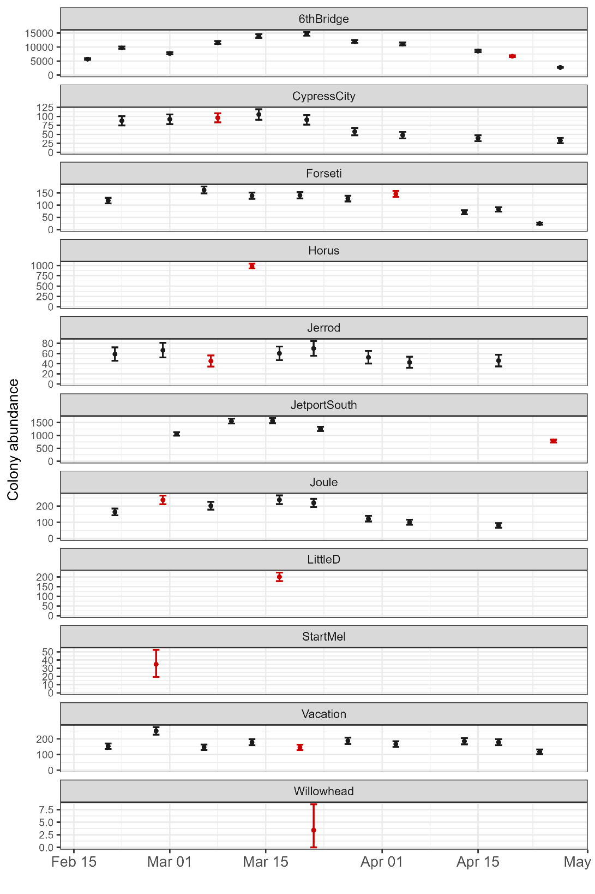
Supplementary Figure S1. Time-series abundance estimates using the developed FP-FN abundance model of the 11 sampled bird colonies in the Florida Everglades. Red points and error bars correspond to the flights that have a subset with algorithm verification and independent human review. The remaining black ones are flights composed only of unverified algorithm counts.

